Project Proposal – Interactive Campus Tour
CS8803, Advanced Internet Applications and Development
Chintan Thakkar, Sandhya Sivaramakrishnan

Abstract

Location Based Services (LBS) have become a popular technology to retrieve information about the surroundings of a mobile user. “Where may I find the nearest restaurant?” is a typical question that can be answered using such services, in form of a map or text directions. The location of the mobile user is therefore one of the most important components of an LBS, in order to present a specific information to the user.

This project proposes to build the infrastructure of LBS for campus of the Georgia Institute of Technology. It develops a prototype using which user can specify its current location on the campus map displayed on the mobile device. This prototype then guides the users according to his interest and work as an interactive campus tour / guide. People who visit the Georgia Tech campus first time, this application serve as their campus guide and customize the campus tour according to users’ time constraint and interest.

Motivation

As mobile devices are growing popular and becoming an indispensable part of everyone’s life, to maximize the features and the services that it can provide to consumers- is a continuous effort for the businesses and a great research topic for researchers.

Revenues generated from location based services are constantly increasing and it will become the dominant factor in the near future. Here, we tried to identify some potential applications of location based services which will be very useful in the near future. Some of the applications / common use of the “Interactive Campus Tour” will be as follows:

- This application serves as an interactive campus tour for the first time visitors. It helps them to reach their destination place with the shortest path and highlight the path on the campus map displayed on the cell phone. User can also find their point of interest (POI) like nearest ATM/bank, food court, CRC, parking place using this application. One interesting feature of this prototype is that, students can find the location of their lecture using course number or by professor name. So, this application provides a complete package of services which are very beneficial to the students to roam around the campus.

- This application can be extended to find friends within a certain geographical area. Application gets the user’s current location and tries to find out the friends which are currently within a certain range. This application is particularly useful at times when user wants to shares his lunch / movie plan with his nearby friends.

- Campus tour can be extended to provide the information about any place rather than just a campus. So, user can specify their source and destination place and application calculate the shortest path using Dijkstra’s shortest path finding algorithm. Current traffic information also integrated within the application, so it displays the shortest path according to the current traffic pattern and provides updated path whenever there is congestion in the network.

- One useful application of the interactive campus tour is that, user can program / learn the system about his daily schedule. So, system generates the best optimal schedule/route of the entire day according to the user’s schedule. Also, system sends HOT / latest news of the campus places according to the users frequently visited places.

- This interactive campus tour can be extended as a virtual tour guide of the entire city. It is very useful for the first time visitors and set the tourist plan according to the user’s timing and money constrains as well as his predefined area of interest.

Related Work
Interactive campus tour which uses the Location based services (LBS) to find the current location of the user and provide them shortest path to their destination is currently implementing at University of New South Wales (UNSW), Australia. They use wireless network approach to determine the approximate location of the user and to get the exact location they required at least three signals from access points to execute the triangulation method. They developed a web based prototype for the system and currently trying to transform it to the mobile device.

Location based prototype system “seeTV” is currently in implementation at Virginia Tech campus, which provides interactive campus tour facility to the VTech campus. The system uses handheld computers as an embodiment of a tour guide to introduce visitors to campus (initial pilot only for Computer Science department). They utilized VTech’s WLAN infrastructure to interpolate the users’ current location and notify them about points of interests in the area. The notification information is also tailored as per user types and preferences. The goal of the system is to provide sufficient information to impart a long lasting comprehension of features in the user’s environment.

Proposed work

The prototype system work as follows:

- User sees the campus map of the Georgia Tech on his cell phone. There is one point for each location on the map. He can specify his current location and his destination location by pointing to that point in the map.
- Microsoft map point server gets the co-ordinates of the point. By using reverse geo-coding we can get the accurate location of the user.
- Dijkstra’s shortest path finding algorithm finds out the most efficient path and using map point API, system can highlight the path on the map.

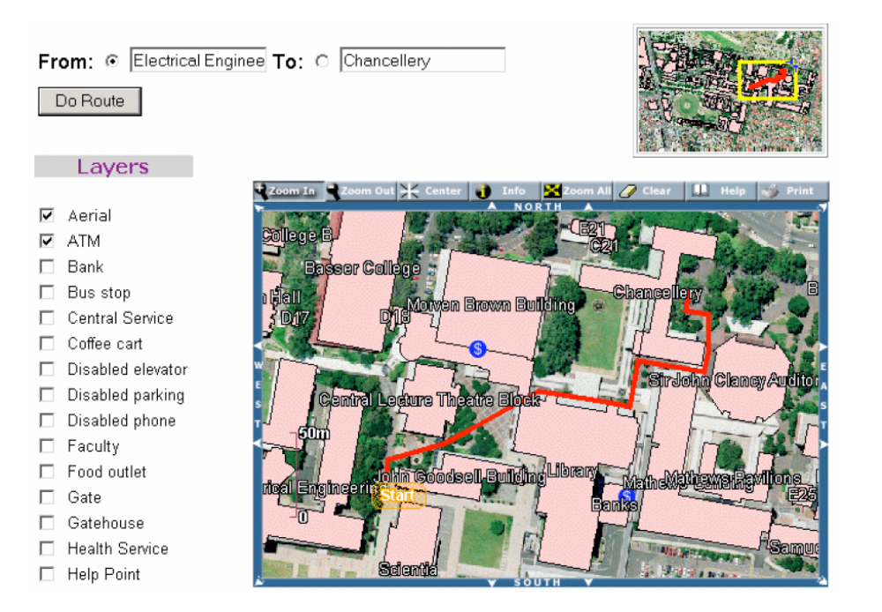
(Featured Web Interface of the “Interactive Campus Tour”)

- For more advanced options, we developed a user interface which facilitates users to specify his preferences. In this case, user can specify his point of interest (POI) like nearest ATM, post office, food court, CRC, parking zone.
- System then calculates the optimal path with reference to the user’s current location and display the path on the map.

- Using interactive campus tour, user can also find course location by either entering course number or instructor name.
- System can fetch the result from the database and render the course location on map.

- There is one another user interface using which user can feed his daily schedule to the system and system then calculates and provides best optimal path by reordering the events whenever possible. System also remembers user preferences and provides latest news according to the user’s location preferences.

Technologies

- Java 2 Micro Edition (J2ME) – At this point, we decided to go with J2ME as it is specifically developed for mobile application development.
- Web services – Map point – We intend to use Microsoft MapPoint web service for fetching the map location from the user.
- Mobile Application Development toolkit / Nokia Emulator– At this point, we do not know which emulator has better functionality and is useful for our application. So, we decided to go with both emulators parallel and try to discover best one.
- GeoFrameworks GPS.NET – GPS dot net ships virtual GPS devices and necessary libraries for programming with the GPS. We intend to use the virtual devices here for this task.

Timeline

The Application development lifecycle will be eight weeks.
- Requirements Gathering, Analysis (2 week)
- Development, Unit Testing (5 weeks)
- System Testing/Documentation (1 week)

Please refer to table 1 below for details on the milestones.

Milestone Date | Milestone Description
16-Feb-06 | Project Proposal
23-Feb-06 | Familiarity with Microsoft Map point
02-Mar-06 | Rendering maps to the mobile screen
09-Mar-06 | Find location of users using geo-coding
16-Mar-06 | User Interface
24-Mar-06 | Spring Break
30-Mar-06 | Dijkstra’s shortest path finding algorithm
06-Apr-06 | System Integration, Run in Emulator
13-Apr-06 | Buffer Time
18-Apr-06 | System Testing
28-Apr-06 | Project Report, Presentation Slides, Demo
Table 1: Project Milestones

Deliverables

Demonstration of the Interactive campus tour with the sample data of Georgia Tech campus map. User can specify his current position by clicking on the map and system displays interactive path to the destination according to the user’s preferences. If time permits, we will implement the voice reorganization facility and peer-to-peer networking for image sharing between groups of users within a certain geographical area.

Due to lack of hardware at this moment we intend to demonstrate only on an emulator. We will be using the Pocket PC 2002 emulator for this purpose.

Future Scope

If real time traffic information is integrated with this application, then it will become a very useful application to the users who want the shortest path to their destination according to current traffic pattern and congestion relative to their current location on their mobile devices.

The application has to be designed in such a way that, it can be customized to any other university campus / place with little or no modification. Also, mobile device has very limited memory and processing capability, all processing has to be done at server side. So, system must be scalable to accommodate new users.

This application can be further extended to accommodate peer-to-peer networking using which mobile users can share the images / files with their friends within a certain geographical area.

System can be incorporated with voice reorganization technology, so user can specify their preferences by voice rather than typing them to the cell phone.

References

- New ideas about location based services
http://www.lbszone.com/

- Microsoft Map point API to render maps on cell phone and get the user’s location
http://msdn.microsoft.com/mappoint

- beginner’s tutorial to develop location based services
http://developers.sun.com/techtopics/mobility/apis/articles/location/

- Interactive campus tour developed at UNSW, Australia.
http://www.gmat.unsw.edu.au/snap/publications/kiener_2003.pdf

- seeTV, prototype for campus tour developed at Virginia Tech.
http://people.cs.vt.edu/~mccricks/papers/seeVT-hcii05.pdf

